TABLE OF CONTENTS
1. SAFETY 2
2. GENERAL DESCRIPTION 3
3. SCHEMATIC BLOCK DIAGRAM 5
4. MAIN PARAMETERS 5
5. INSTALLATION & OPERATION 6
6. CAUTIONS 24
7. MAINTENANCE 25
8. TROUBLESHOOTING 26
9. WIRING DIAGRAM 29
APPENDIX: PROGRAMMING GUIDE FOR USERS (TIG MODE) 30

DECLARATION
SHENZHEN JASIC TECHNOLOGY CO., LTD. solemnly promises: This product is manufactured according to relevant standards of China and relevant international standards, and meets IEC60974-1 international safety standard. Relevant design plans and manufacturing technologies of this product are patented.

Operate after reading this manual carefully.
- JASIC has the right to modify this manual at any time without prior notice.
- Though contents in this manual have been carefully checked, inaccuracies might have occurred. For any inaccuracy, please contact us.
- This manual was released in Sep, 2012.

SHENZHEN JASIC TECHNOLOGY CO., LTD.
Address: No. 3, Qinglan 1st Road, Pingshan District, Shenzhen, Guangdong, China
Postcode: 518118
Tel: 0755-29651666 Fax: 0755-27364108
Website: http://www.jasictech.com E-mail: sales@jasictech.com

1. SAFETY
Welding is dangerous, and may cause damage to you and others, so take good protection when welding. For details, please refer to the operator safety guidelines in conformity with the accident prevention requirements of the manufacturer.
 | Professional training is needed before operating the machine.  - Use labor protection welding supplies authorized by national security supervision department.  - Operators should be with valid work permits for metal welding (cutting) operations.  - Cut off power before maintenance or repair.
 | Electric shock—may lead to serious injury or even death.  - Install earth device according to the application criteria.  - Never touch the live parts when skin bared or wearing wet gloves/clothes.  - Make sure that you are insulated from the ground and workpiece.  - Make sure that your working position is safe.
 | Smoke & gas—may be harmful to health.  - Keep your head away from smoke and gas to avoid inhalation of exhaust gas from welding.  - Keep the working environment well ventilated with exhaust or ventilation equipment when welding.
 | Arc radiation—may damage eyes or burn skin.  - Wear suitable welding masks and protective clothing to protect your eyes and body.  - Use suitable masks or screens to protect spectators from harm.
 | Improper operation may cause fire or explosion.  - Welding sparks may result in a fire, so please make sure no combustible materials nearby and pay attention to fire hazard.  - Have a fire extinguisher nearby, and have a trained person to use it.  - Airtight container welding is forbidden  - Do not use this machine for pipe thawing.
 | Hot workpiece may cause severe scalding.  - Do not touch hot workpiece with bare hands.  - Cooling is needed during continuous use of the welding torch.
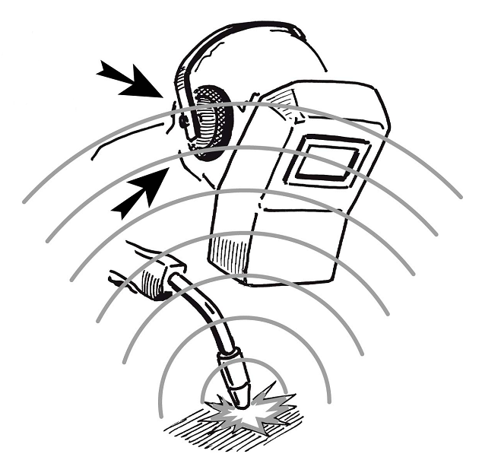 | Noise may be harmful to people’s hearing.  - Wear approved ear protection when welding.  - Warn spectators that noise may be harmful to their hearing.
 | Magnetic fields affect cardiac pacemaker.  - Pacemaker users should be away from the welding spot before medical consultation.
 | Moving parts may lead to personal injury.  - Keep yourself away from moving parts such as fan.  - All doors, panels, covers and other protective devices should be closed during operation.
 | Please seek professional help when encountering machine failure.  - Consult the relevant contents of this manual if you encounter any difficulties in installation and operation.  - Contact the service center of your supplier to seek professional help if you still can not fully understand after reading the manual or still can not solve the problem according to the manual.

2. GENERAL DESCRIPTION
This is a digital AC/DC inverter welding machine with perfect function, excellent performance and advanced technology. It has various AC/DC non-melting inert gas welding function such as AC square-wave TIG, AC pulsed TIG, DC TIG, DC pulsed TIG, AC SMAW, DC SMAW, TIG spot welding (DC, pulsed or AC), and composite waveform TIG, etc., and it can be widely used in fine welding of various metals.
The foresighted design and advanced and mature technologies of this machine would protect users’ investment to the maximum extent.
2.1 Advanced digital control
This machine adopts advanced MCU intelligent digital control technology, and all its major parts are performed through software. It is a digital control welding machine, improved a lot in its function and performance when compared with the traditional welding machine.
2.2 Advanced inverter technology
The primary inverter frequency is 100 KHz, which greatly reduces the volume and weight of the welder. Great reduction in magnetic and resistance loss obviously enhances the transformer efficiency and energy saving effect. Working frequency is beyond audiorange, which almost eliminates the noise pollution.
2.3 Perfect automatic protection function
When the mains voltage fluctuates sharply, the welding machine will automatically stop working with the fault information displayed, and it will automatically recover after the mains voltage turns stable. Besides, in the case of overcurrent or overheating, the machine will stop working automatically with the fault information displayed. Such protection function greatly increases the lifespan of the machine.
2.4 Good consistency and stable performance
This machine adopts intelligent digital control, so it is insensitive to the change of parameters of components. That is, the performance of welding machine will not be affected by the change of the parameters of certain components. Besides, it is insensitive to the change of the working environment such as temperature and humidity, etc. Therefore, the consistency and stability of digital control welder is better than that of traditional welder.
2.5 Parameter easy to adjust and software easy to update
Generally speaking, for a welding machine with analogue circuit control or with analogue circuit & digital circuit control, the adjustment of most parameters should be achieved through the corresponding circuit, so if more parameters to be adjusted, the circuit would be more complicated and more difficult to be achieved. However, for a welding machine with intelligent digital control, the adjustment of parameters is much easier and more accurate, because its main function is achieved through software. To change the function or some of the parameters, you do not need to change the circuit, and the only thing you have to do is to download the updated software.
2.6 User-friendly interface
This machine adopts international standard graphic language interface, which is simple, vivid, intelligible, and convenient for users’ operation.
2.7 Practical welding process management function
The machine allows users to divide the welding parameters into five groups, according to different techniques during operation, each of which can complete a particular welding task. It undoubtedly facilitates the technical standardization management in welding production.
2.8 High-quality MMA welding
MMA welding performance is significantly improved with excellent control algorithm: easier to ignite arc, stable welding current, little spatter, no electrode sticking, good shaping, and adaptable to the change of length or section of welding cable.
2.9 High-quality TIG welding
Improved digital technology for constant current ensures the low noise and a high stability of arc quality as well. Meanwhile, the mature control algorithm provides users with a convenient and practical approach to control the current freely. Totally 20 TIG operation modes, including the typical 2T/4T, and 4 of them are programmable, which offers a favorable approach for user‘s special application.
2.10 Remote control available
The machine offers an analog remote control mode (foot control), which can realize real-time adjustment of TIG welding current over 10m away.
2.11 Robot system for automatic welding available
The machine is provided with RS-485 communication interface, and it is easy for users to compose an automatic welding system with other equipment with the embedded standard ModBus communication protocol. Contact our company for a special order if necessary.
2.12 Perfect automatic recording function
All data such as cumulative startup times, cumulative running time, cumulative welding time, cumulative TIG welding time, accumulative MMA welding time, cumulative times of alarm, cumulative times of overcurrent, cumulative times of overheating, cumulative times of undervoltage and cumulative times of water-cooling alarm can be calculated and stored in FLASH memory. And also, these data can be obtained through the RS-485 serial interface, providing a basis for maintenance. Meanwhile, it is a good preliminary preparation for remote maintenance.
2.13 Control interface for automatic welding equipment available
This machine provides torch trigger signal, current signal and fault alarm signal for connection with automatic welding equipment. Thus, automatic welding can be obtained easily.
2.14 Wide input voltage range adaptable
Welding can be carried out under 3-phase AC 280-420V with this machine.

3. SCHEMATIC BLOCK DIAGRAM
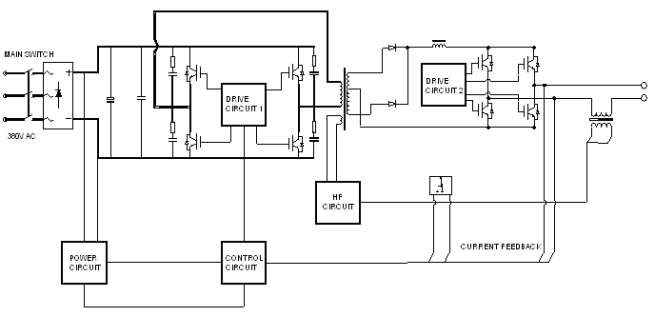

4. MAIN PARAMETERS
Common parameter
Input voltage Range | 3-phase 280~420V AC, 50/60Hz
Rated input capacity (KVA) | 9
Rated input power (KW) | 8.4
Recommended fuse capacity (A) | 40
Rated output (A/V) | TIG: 315/22.6; MMA: 250/30
Rated duty cycle (%) | 60
No-load voltage (V) | 50
Insulation class | F
Cooling mode | Forced air cooling
Protection class | IP23
Overall size (mm) | 590×375×380
Weight (kg) | 33

Parameters in MMA (DC, AC)
Welding current range (A) | DC: 10~250; AC: 20~250
Arc ignition current range (A) | DC: 10~300; AC: 20~300
Arc force current range (A) | 0~100
AC frequency (Hz) | 50

Parameters in TIG (DC, DC pulsed, AC, AC pulsed)
Initial current range (A) | DC: 10~320; AC: 20~250
Peak current range (A) | DC: 10~320; AC: 30~320
Base current range (A) | DC: 10~320; AC: 30~320
Crater current range (A) | DC: 10~320; AC: 20~250
DC pulse frequency range (Hz) | 0.5~200
DC pulse duration ratio range (%) | 10~90
AC frequency range (Hz) | 20~70
Positive and negative half-wave time ratio (%) | 10~60
AC pulse frequency range (Hz) | 0.5~5.0
AC pulse duration ratio range (%) | 10~90
Upslope time (s) | 0~60
Downslope time (s) | 0~60
Pre-flow time (s) | 0~15.0
Post-flow time (s) | 0~20.0
Spot welding time (s) | 0.0~8.9
Arc ignition mode | Contact arc ignition, HF arc ignition

5. INSTALLATION & OPERATION
 | Please install the machine strictly following the steps in this section.

 | Electric shock can cause personal injury or even can kill.

Working environment of machine
- Welding should be carried out in dry environment with its humidity not greater than 90%.
- The temperature of the working environment should be between -10℃ to 40℃.
- Avoid welding in the open air unless sheltered from sunlight and rain. Keep it dry anytime and do not place it on wet ground or in puddles.
- Avoid welding in dusty area or environment with corrosive chemical gas.
- Gas shielded arc welding should be operated in environment without strong wind.
- Ensure good ventilation: This welder can create powerful welding current that has strict cooling requirements that cannot be met with natural ventilation. Therefore the built-in fan is very important in enabling the machine to work stable with effective cooling. The operator should make sure that the louvers be uncovered and unblocked. The minimum distance between the machine and nearby objects should be 30cm. Good ventilation is of critical importance to the normal performance and lifespan of the machine.
5.1 Front panel
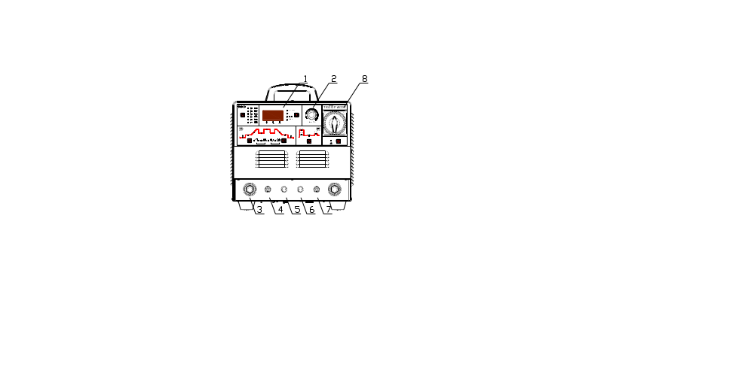 | - Front panel film  (Welding mode and parameter selecting)  - Adjustment knob  (Welding mode and parameter adjusting)  - Quick output socket  - Output terminal of shield gas  - Socket for torch trigger input  - Socket for foot control  - Quick socket for water cooling (output)  - Power switch
5.2 Back panel
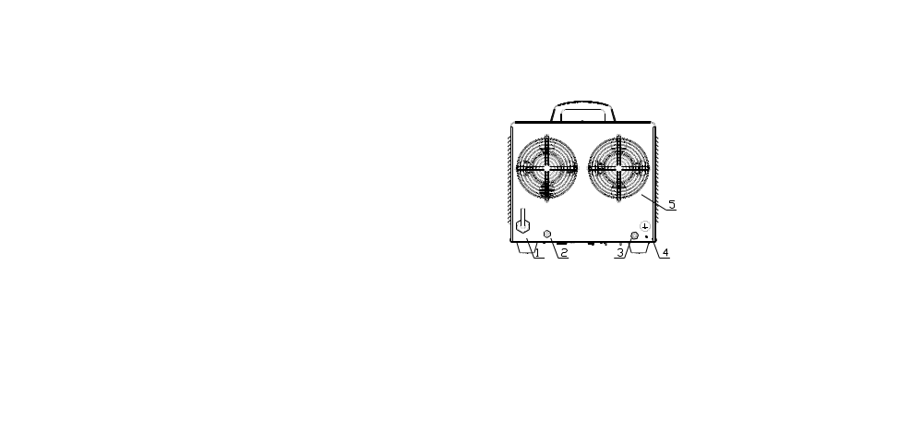 | - 3-phase input cable junction box (4-wire)  - Quick socket for water cooling (input)  - Input terminal of shield gas  - Ground terminal  - Fan guard
5.3 Input connection
 | Cut off the power supply before any electric connection operation.
5.3.1 Power cord connection
The power supply of this machine is 380V 3-phase (50/60Hz), and an input power cord (4*2.5mm²) about 3m is provided with this machine. Users should connect it to the switching box, and the switching box should meet the power requirement of the machine. Please refer to the figure on the next page for the connection.
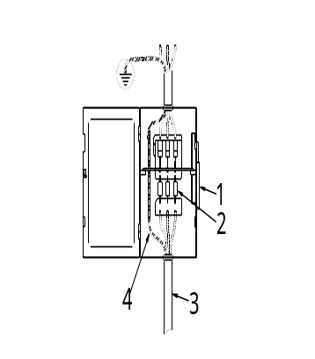  Connection of switching box | - Power switch of the switching box  - Fuse with a capacity of 40A or more  - Input power cord of the welding machine  - Yellow-green earth wire (earth, not connect to the null line)  Connect according to the figure on the left or in other correct ways. Cut off the main power before connection.  Note: No operation with electricity on.
- Ask professional electrician to do the connection.
- Do not connect two welding machines to the same switching box.
- Wire 4 is unnecessary to be earthed if the machine enclosure is earthed.
5.3.2 Grounding of welding machine
A ground terminal marked with “” is available on the back panel of the machine. Users may ground the machine via this terminal if no ground terminal is provided in the switching box.
Note: The ground wire should be connected tightly to avoid any potential safety hazards.
5.4 Panel film
The panel film is the platform for the operator to communicate with the welder. See the below picture for the panel film of this machine. For your better understanding, some arrows are added in the picture, and functions of all components are noted below.

1—Welding mode selecting zone
It is used to select the welding mode. Press the key in this zone to shift the welding mode among “” (AC square-wave TIG), “” (AC pulsed TIG), “” (DC TIG), “” (DC pulsed TIG), “” (AC SMAW) and “” (DC SMAW) with the corresponding LED shining. However, if the LED glitters, it indicates that welding is being carried out in the corresponding welding mode and that shifting cannot be performed.
2—Parameter and alarm display zone
The digital meter is used for displaying the parameters and error codes, and it also displays the software version when stating the machine. The details are as below.
- Generally, the digital meter displays the preset current, time, pulse duration ratio and frequency with the corresponding LED “A S % Hz” shining. Parameters can be adjusted by turning the knob. The digital meter displays the welding current during welding, and parameters can be adjusted at this time as well. It displays the parameter being adjusted, and turns to display the welding current 3s after the adjustment.
- Press the key “↓” in this zone to shift the display of the digital meter among “A S % Hz”, “V”, “” and “MEMORY” with the corresponding LED shining. “V” indicates the output voltage; “” is used for selecting the operation mode of TIG welding (For the 20 operation modes, please refer to the contents in Section 5.6 ); “MEMORY” can store 5 groups of parameters, and users may perform welding conveniently with these parameters.
- The digital meter displays the software version after the machine is started, and displays the preset current 2s later.
- In normal condition, all alarm LEDs are off. In case of any error, the corresponding LED will illuminate, and the digital meter will display the corresponding error code.
When the “OC” LED illuminates and the digital meter displays “E-0” or “E-1”, it indicates that overcurrent occurs. Restart the machine, and welding can be continued.
When the “LV/OV” LED illuminates and the digital meter displays “E-2”, it indicates that the mains voltage is overly low or that the secondary inverter drive power source fails. In the former condition, welding can be recovered when the mains voltage goes into normal. In the latter condition, please ask professionals to do the checking.
When the “OH” LED illuminates and the digital meter displays “E-3” or “E-4”, it indicates that welding is forced to stop because the main circuit of the machine gets overheated. In this condition, It is unnecessary to turn off the machine, but just wait a few minutes, and then welding can be continued.
3—Parameter adjustment knob
It is used to adjust all adjustable parameters.
4—Hole site for the welding power source breaker
5—TIG parameter selecting zone
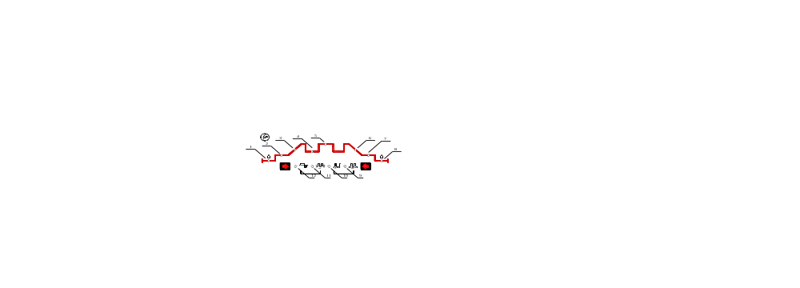
1-Pre-flow time 2-Initial current 3-Upslope time 4-Base current
5-Peak current 6-Downslope time 7-Pilot arc current 8-Post-flow time
9-Pulse frequency 10-Pulse duration ratio 11-AC frequency 12-Cathode current
Press “→”, and parameter will shift from 1 to 12 in sequence; press “←”, and parameter will shift from 12 to 1 in sequence. Users can set the parameter with the parameter adjustment knob after selecting a parameter.
6—MMA parameter selecting zone
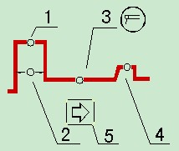
1-Arc ignition current
2-Arc ignition time
3-Welding current
4-Arc force current
5-MMA parameter selecting key
7—Foot control selecting zone
Select the foot control to control the welding current by pressing the foot control key with the LED on. The welding current should be 30A at least (to avoid arc breaking due to overly low current) and should not be higher than the preset current. The foot control is effective only in TIG mode.
5.5 Parameter setting
Operation hints | Selection and adjustment of parameters
● Press “↓” in parameter display selecting zone to select the parameter to be displayed.
● Press “↓” in welding mode selecting zone to select welding mode (totally 6 welding modes).
● Press “←”or “→” in TIG parameter selecting zone to select parameter in TIG. (only in TIG mode)
● Press “→”in MMA parameter selecting zone to select parameter in MMA. (only in MMA mode)
● Turn the adjustment knob to set or amend the parameter currently selected.

Operation hints | Parameter storage
The parameters having been adjusted will be autosaved in the parameter group currently used (no autosaving will be done in the case that no operation is done after parameters are adjusted and the machine was turned off in 3s’ time). When the machine is turned on next time, the parameters in this parameter group are just the parameters used last time. No special save key and manual saving operation is available for this machine.

Concept hints | Parameter group
5 parameter groups (1-5) are available for users to save the welding parameters based on welding application, and all parameters in all the six welding modes can be saved in each parameter group. Every time when the machine is turned on, it is under the parameter group of last time when the machine is turned off. If users do not rechoose the parameter group, the machine will continue its working under this parameter group. Users can set different parameters in different parameter groups and select corresponding one to weld. (Note: Parameters in all the five parameter groups are the same and are all default when using the machine for the first time.)
5.5.1 Parameter group selecting
In standby mode, press “↓” in parameter and alarm display zone to lighten the “MEMORY” LED, and at this time, what the digital meter displays is the No. of the parameter group being used. Turn the adjustment knob, the parameter group No. will be changed, and you can select the desired parameter group. After selecting the parameter group, you can repress “↓” to exit, or you can wait for about 10s till the machine return to parameter display status automatically.
5.5.2 DC TIG welding
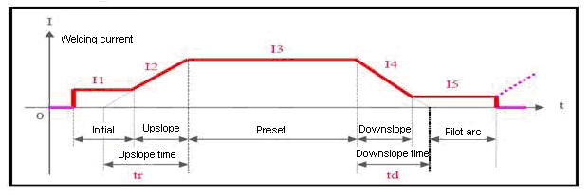
Current change in DC TIG
In DC TIG mode, 8 adjustable parameters are available for this machine. Describe them as below.
- Current (I3): This parameter can be set according to users’ own technical requirements.
- Initial current (I1): It is the current when arc is ignited by pushing the torch trigger, and it should be set according to users’ own technical requirements. If the initial current is high enough, arc is easier to ignite. However, it should not be too high when welding thin plate, so as to avoid burn through the workpiece during arc ignition. In some operation modes, the current does not rise but stay at the initial current value to preheat the workpiece or illuminate.
- Pilot arc current (I5): In some operation modes, the arc does not stop after current downslope but stay in the pilot arc state. The working current in this state is called pilot arc current, and it should be set according to users’ technical requirements.
- Pre-flow time: It indicates the time from the torch trigger being pushed to arc being ignited in non-contact mode. Commonly it should be longer than 0.5s to make sure that the gas has been delivered to the welding torch in normal flow before arc ignition. The pre-flow time should be increased if the gas hose is long.
- Post-flow time: It indicates the time from the welding current being cut off to the gas valve inside the machine being closed. If it is too long, it will lead to a waste of argon gas; if it is too short, it will result in the oxidation of weld bead. When in AC TIG or for special materials, the time should be longer.
- Upslope time (tr): It indicates the time spent on current rising from 0 to the preset value, and it should be set according to users’ technical requirements.
- Downslope time (td): It indicates the time spent on current dropping from the preset value to 0, and it should be set according to users’ technical requirements.
- TIG operation modes: Please refer to Section 5.6.
Recommended parameters in TIG
Electrode dia. (mm) | Stainless steel thickness (mm) | Maximum current (A) | Maximum gas flow (l/min)
1∼2 | 1∼3 | 50 | 5
1∼2 | 1∼3 | 50~80 | 6
2∼4 | 3∼6 | 80~120 | 7
2∼4 | 3∼6 | 121~160 | 8
2∼4 | 3∼6 | 161~200 | 9
2∼4 | 3∼6 | 201~300 | 10

5.5.3 Pulsed TIG welding
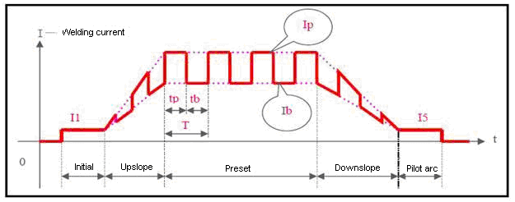
Current change in pulsed TIG welding
In pulsed TIG mode, all DC TIG parameters except current (I3) and another 4 adjustable parameters are available for this machine. Describe them as below.
- Peak current (Ip): It should be adjusted according to users’ technical requirements.
- Base current (Ib): It should be adjusted according to users’ technical requirements.
- Pulsed frequency (1/T): T=Tp+Tb. It should be adjusted according to users’ technical requirements.
- Pulse duration ratio (100%*Tp/T): The percentage peak current time holding in pulse period. It should be adjusted according to users’ technical requirements.
5.5.4 AC square wave TIG welding
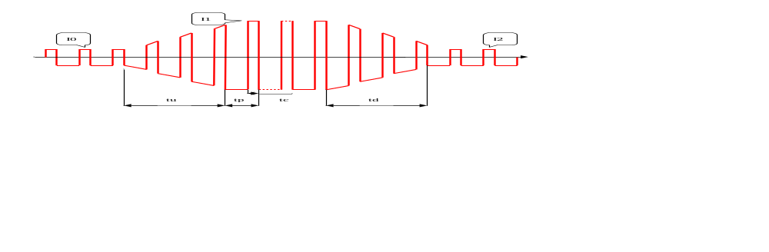
I0-Initial current, I1-Welding current, I2-Pilot arc current,
tu-Upslope time, td-Downslope time
tp-AC period, tc-Cathode current time
Current change in AC square wave TIG welding
In AC square wave TIG welding, the pre-flow time and post-flow time are the same with those in DC TIG welding, and others are described as below.
- Initial current (I0), welding current (I1) & pilot arc current (I2): The preset value of the three parameters is approximately the absolute average of the practical welding current, and can be adjusted according to users’ technical requirements.
- Pulse frequency (1/tp): It can be adjusted according to users’ technical requirements.
- Cleaning strength (100%*Tc/Tp): Generally, in AC welding, when taking the electrode as anode, the current is called cathode current. Its main function is to break up the oxidized layer of the workpiece, and the cleaning strength is the percentage cathode current holding in the AC period. This parameter is 10~40% commonly. When the value is smaller, arc is concentrative, molten pool is narrow and deep, and when it is bigger, arc is dispersive, molten pool is wide and shallow.
5.5.5 AC pulsed TIG welding
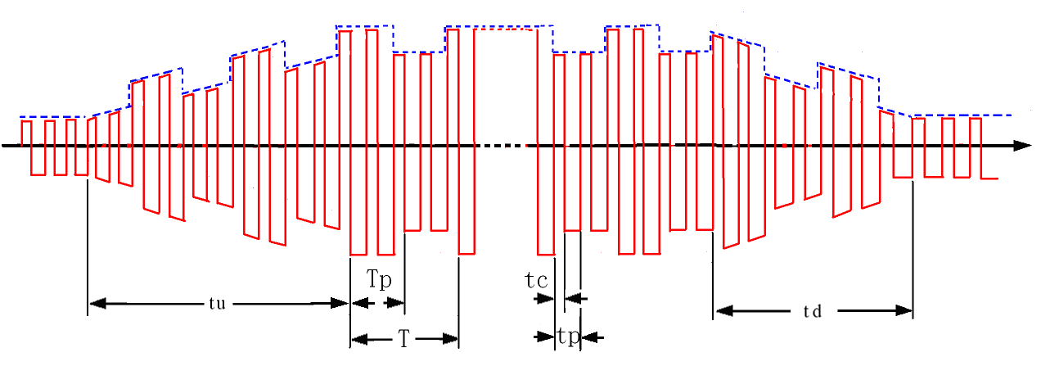
tc-Cathode current time, tp-AC period
Tp-Pulsed peak current time, T-Pulse period
Current change in AC pulsed TIG welding
AC pulsed TIG welding is almost the same as AC square wave TIG welding, and what makes them different is that in AC pulsed TIG welding, the welding current varies with the pulse and peak current and base current are generated because the welding current is controlled by a low frequency pulse. The preset peak current and base current are the low frequency pulse peak value (average value) and base value (average value) respectively. For the AC square wave parameter selecting and setting, please refer to the corresponding contents in AC square wave TIG welding. For the pulse frequency and pulse duration ratio, users may refer to the corresponding contents in DC pulsed TIG welding. The pulse frequency (1/T) is a little low, and it can be adjusted between 0.5Hz and 5Hz. The pulse duration ratio (Tp/T) can be adjusted between 10% and 90%.
5.5.6 TIG spot welding
Select TIG operation mode 1 (refer to Section 5.6), and TIG spot welding function can be achieved. Spot welding is available in all the four TIG welding modes. Please note that the spot welding time is 1/10 of the upslope time, and that the upslope time is still the preset value. For current change in DC TIG spot welding, pulsed TIG spot welding, AC TIG spot welding and AC pulsed TIG spot welding, please refer to the figures below. In AC mode, the preset value of spot welding current is approximately the absolute average of welding current, other than the peak value.
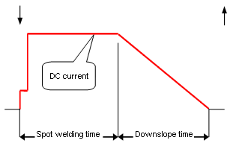  Current change in DC TIG spot welding | 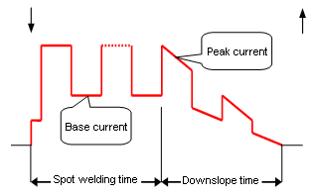Current change in pulsed TIG spot welding

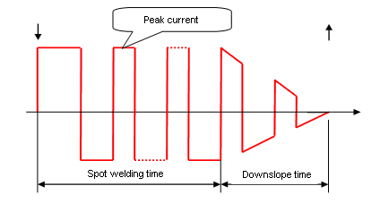  Current change in AC TIG spot welding | 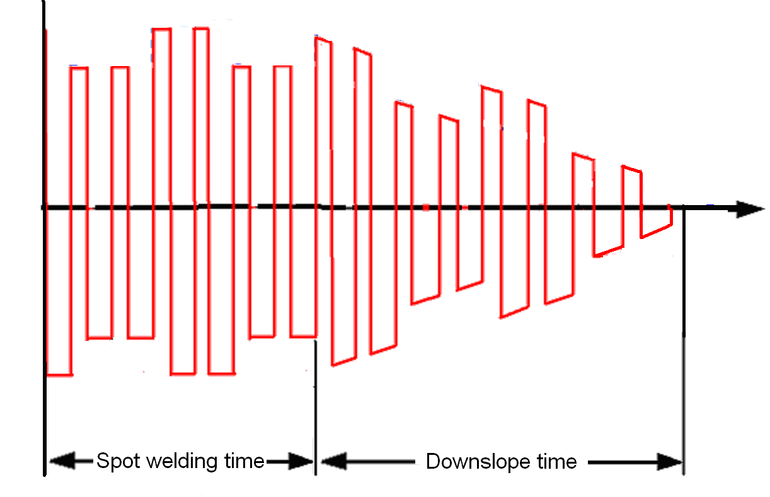  Current change in AC pulsed TIG spot welding
5.5.7 Complex waveform TIG welding
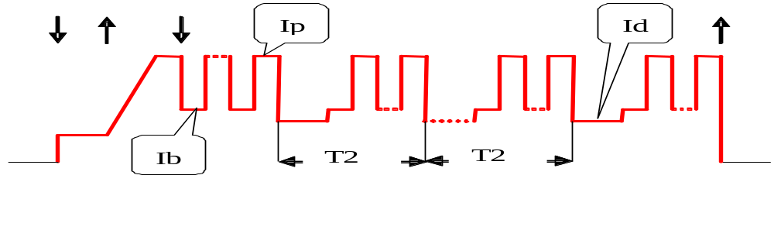
Current change in complex waveform DC pulsed welding
This machine can obtain complex waveform TIG welding through programming. Special pulsed welding can be obtained in DC TIG mode, dual-pulse welding can be obtained in pulsed TIG mode, and variable polarity pulsed welding can be obtained in AC TIG mode. To obtain complex waveform TIG welding, it is necessary to select the appropriate TIG operation mode or reprogram the TIG operation mode according to the appendix Programming Guide for Users (TIG mode). Take complex waveform DC pulsed welding for example. By adding a pulsed current with higher frequency to the peak pulsed current with lower frequency, some special welding requirements can be met. Complicated complex waveform DC pulsed welding can be obtained by selecting the operation mode 18/19 or self-programming in pulsed welding mode. A typical waveform of complex waveform DC pulsed welding (operation mode 18) is showed in the above figure, in which, Ib and Ip stand for the base current and peak current in pulsed welding mode respectively. Id ‘s value is equal to that of the pilot arc current, but it has no sense of pilot arc current, and it can be considered as secondary base current. T2 stands for the period of the secondary pulse (LF), and here in this example T2 is 200ms. In operation mode 19, the period of the secondary pulse (LF) can be changed at any moment by adjusting the upslope time.
5.5.8 SMAW (DC)
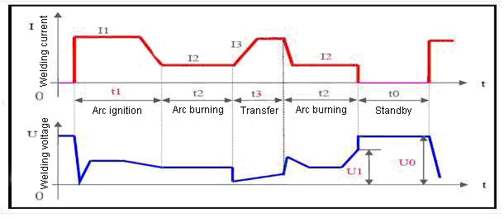
Note: t0—Standby: No welding current; output voltage is the no-load voltage.
t1—Arc ignition: Welding current is arc ignition current (I1).
t3—Arc burning: Welding current is the preset current (I2).
t4—Short-circuit transfer: Welding current is the short-circuit transfer current (I3).

In SMAW mode, 4 parameters that can be adjusted directly and 1 parameter that can only be adjusted through programming are available for this machine. Describe them as below.
- Current (I2): This is the welding current when arc is burning, and users can set it according to their own technical requirements.
- Arc force: It refers to the ascending slope of the current in short circuit, and it is set as the amperage increased per millisecond in this machine. The current will ascend from the preset value by this slope after short circuit occurs. (E.g. When the preset current is 100A and the arc force is 20, the current will be 200A 5ms after short circuit occurs.) If it is still under short circuit when the current increases to the allowable maximum value 250A, the current will not ascend any more. If the short circuit status lasts for 0.8s or more, the machine will enter into electrode sticking process: to wait the disconnection of the electrode under low current. Arc force should be set according to the electrode diameter, preset current and the technical requirement. If the arc force is big, the molten drop can be transferred quickly, and electrode sticking seldom occurs. However, too big arc force may lead to excessive spatter. If the arc force is small, there will be little spatter, and the weld bead will be shaped well. However, too small arc force may lead to soft arc and electrode sticking. Therefore, the arc force should be increased when welding with thick electrode under low current. In general welding, the arc force may be set at 5~50.
- Arc ignition current (I1) and arc ignition time (T1): Arc ignition current is the output current of the machine when the arc is ignited. Arc ignition time is the time the arc ignition current lasts. When in non-contact ignition mode, neither parameter makes sense. When in high current ignition mode, the arc ignition current is generally 1.5~3 times the welding current, and the arc ignition time is 0.02~0.05s. When in low current ignition mode, the arc ignition current is generally 0.2~0.5 times the welding current, and the arc ignition time is 0.02~0.1s.
Operation hints | Arc ignition modes in SMAW
- Low current arc ignition: This can be also called lift/soft arc ignition. Set the arc ignition current (I1) to be a value lower than I2 and the machine will enter into low current arc ignition mode. Touch the workpiece with the electrode, and lift the electrode to the normal position to weld after arc is ignited.
- High current arc ignition: This can be also called contact/thermal arc ignition. Set the arc ignition current (I1) to be a value not lower than I2 and the machine will enter into high current arc ignition mode. Touch the workpiece with the electrode, and normal welding can be carried out without lifting the electrode.
- Arc breaking voltage (U1): This parameter is used for setting the arc breaking voltage during welding. It is specially designed to meet the requirement in HF intermittent welding, and its resolution is 0.1V. The arc breaking voltage indicates the maximum allowable arc voltage during welding, that is to say, welding can be continued when the arc voltage is lower than U1, or else welding will stop immediately. This parameter can not be simply adjusted like other parameters, and should be adjusted by the following method.
Operation hints | Arc breaking voltage programming
- Enter into the amendment state: Press the MMA parameter selecting key and turn on the machine, and the parameter display meter will glitter “P-1”, which will disappear 5s later. At this time, the voltage LED will turn on, and the machine will enter into arc breaking voltage amendment state.
- Amend the arc breaking voltage: After entering into arc breaking voltage amendment state, what the parameter display meter shows is the effective arc breaking voltage before amendment. You can amend it to your desired value by turning the knob.
- Exit the amendment state: Exit by pressing the MMA parameter selecting key after amendment. At this time, the new arc breaking voltage comes into being and it can be automatically saved.
Note: In general welding, the arc breaking voltage should be above 45V. If it is too low, arc breaking will occur during welding.
Recommended parameters in SMAW
Electrode diameter (mm) | Recommended welding current (A) | Recommended welding voltage (V)
1.2 | 20~40 | 20~22
1.6 | 30~60 | 21~23
2.0 | 50~90 | 22~24
2.5 | 80~120 | 23~25
3.2 | 100~140 | 24~26
4.0 | 140~180 | 26~28
4.8 | 180~220 | 27~29
6.0 | 220~255 | 28~31
Note: This table is suitable for mild steel welding. For other materials, consult related materials and technical manuals for reference.
5.5.9 SMAW (AC)
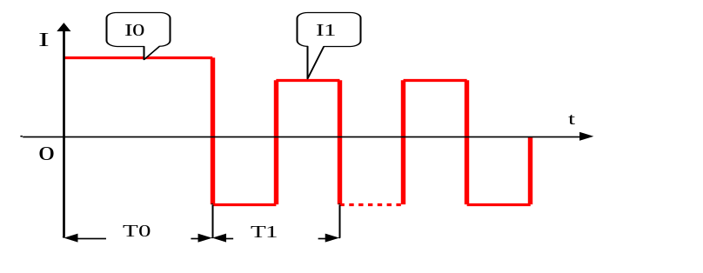 | T0-Arc ignition time (0.01~1s)  T1-AC period (20ms)  (i.e. frequency=50Hz)  I0-Arc ignition current (20~300A)  I1-Welding current (20~250A)

In SMAW AC mode, the adjustment of all parameters is the same with that in SMAW DC mode except that the arc force is 0 fixed.
5.6 TIG operation mode
TIG operation mode is a kind of special stipulation, which stipulates the modes to control welding current through different operation of the torch trigger in TIG (DC TIG, pulsed TIG and AC TIG) welding. The introduction of TIG operation mode strengthens the application of remote control function of the torch trigger, so that users can get practical remote controls for welding machines without further investment.
20 TIG operation modes are available for this machine, in which 0-15 can not be amended by users, and 16-19 can be amended. If you want to amend the TIG operation modes, please refer to the appendix Programming Guide for Users (TIG mode).
TIG operation mode should be selected according to users’ technical requirements and operating habits. All the 20 TIG operation modes for this machine are listed in the table TIG operation modes below.
Torch trigger operation notes
 | Push the torch trigger. |  | Release the torch trigger.
 | Push the torch trigger and then release it at any time. |  | Release the torch trigger and then push it at any time.
 | Push and release the torch trigger within 0.5s, or release and push the torch trigger within 0.5s. |  | Push the torch trigger twice within 0.5s, or release the torch trigger twice within 0.5s.
TIG operation modes
Mode no. | Operation | Torch trigger operation and current curve
0 | Follow mode:  - Push the torch trigger: arc is ignited and current rises to the preset value.  - Release it: arc stops. | 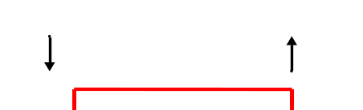
1 | 1T/Spot welding mode:  - Push the torch trigger: arc is ignited and current rises to the preset value.  - When the spot welding time is up, current drops gradually, and arc stops.  Note: Spot welding time is 1/10 of the upslope time. | 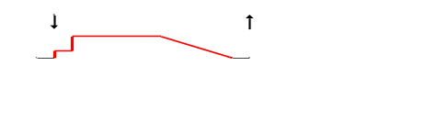
2 | Standard 2T mode:  - Push the torch trigger: arc is ignited and current rises gradually.  - Release the torch trigger: current drops gradually, and arc stops.  - If push the torch trigger again before arc stops, the current will gradually rise again, and then turn to ②. | 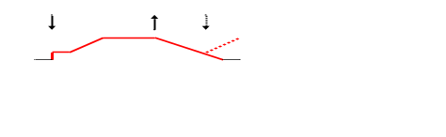
3 | Double operation 2T mode:  - Push the torch trigger: arc is ignited and current rises gradually. The torch trigger can be released at any time.  - Push it again: current drops gradually, and arc stops. The torch trigger can be released at any time.  - If push the torch trigger again before arc stops, the current will gradually rise again, and then turn to ②. | 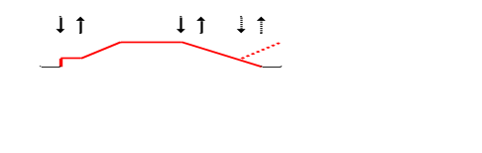

4 | Standard 4T mode:  - Push the torch trigger: arc is ignited and current reaches the initial value.  - Release it: current rises gradually.  - Push it again: current drops to pilot arc current value.  - Release it: arc stops. | 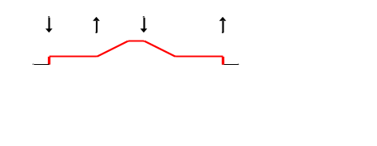
5 | Double operation 4T mode:  - Push the torch trigger: arc is ignited and current reaches the initial value. The torch trigger can be released at any time.  - Release it: current rises gradually. The torch trigger can be released at any time.  - Push it again: current drops to pilot arc current value. The torch trigger can be released at any time.  - Release it: arc stops. | 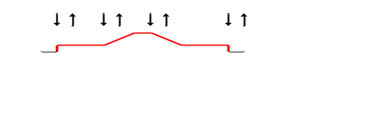
6 | Cycle single operation mode without initial current:  - Push the torch trigger: arc is ignited and current rises gradually.  - Release it: current drops to pilot arc current value.  - Push it again: current rises gradually again, and then turn to ②.  - If push the torch trigger and release it at once, arc will stop. | 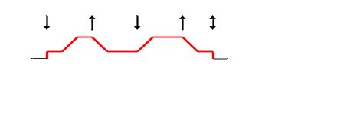
7 | Cycle single operation mode with initial current:  - Push the torch trigger: arc is ignited and current reaches the initial value.  - Release it: current rises gradually.  - Push it again: current drops to pilot arc current value, and turn to ②.  - If release the torch trigger and push it at once, arc will stop. | 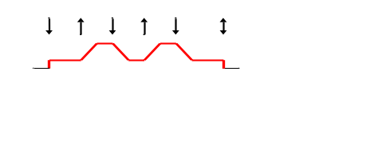
8 | Inner timing operation mode:  - Push the torch trigger: arc is ignited and current rises gradually.  - If release it within 1s, arc will stop; if release it after 1s, it will turn to ③.  - Push it again: current drops gradually, and arc stops. The torch trigger can be released at any time.  - If push the torch trigger again before arc stops, the current will gradually rise again, and then turn to ③. | 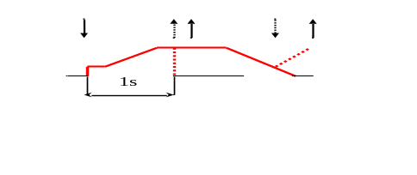

9 | Outer timing operation mode:  - Push the torch trigger: arc is ignited and current rises gradually.  - If release it within 1s, it will turn to ③; if release it after 1s, arc will stop.  - Push it again: current drops gradually, and arc stops. | 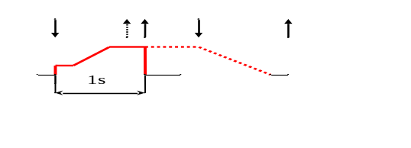
10 | Cycle double operation mode without initial current:  - Push the torch trigger: arc is ignited and current rises gradually. The torch trigger can be released at any time.  - Push the torch trigger and release it at once: current drops to pilot arc current value.  - Push the torch trigger and release it at once: current gradually rises again, and then turn to ②.  - If push the torch trigger twice within 0.5s, the current will drop gradually, and arc will stop. | 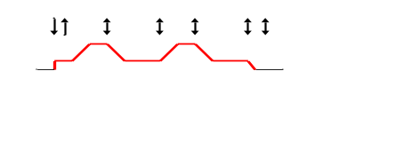
11 | Cycle double operation mode with initial current:  - Push the torch trigger: arc is ignited and current reaches the initial value. The torch trigger can be released at any time.  - Push the torch trigger and release it at once: current gradually rises.  - Push the torch trigger and release it at once: current drops to pilot arc current value, and then turn to ②.  - If push the torch trigger twice within 0.5s, the current will drop gradually, and arc will stop. | 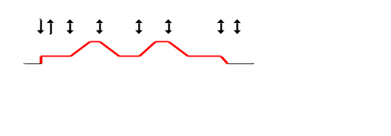
12 | Single operation 3T mode:  - Push the torch trigger: arc is ignited and current rises gradually.  - Release it: current drops to pilot arc current value.  - Push it again: arc stops. | 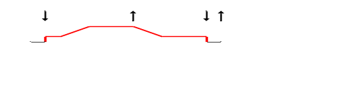
13 | Double operation 3T mode:  - Push the torch trigger: arc is ignited and current rises gradually. The torch trigger can be released at any time.  - Push the torch trigger and release it at once: current drops to pilot arc current value.  - Push it again: arc stops. | 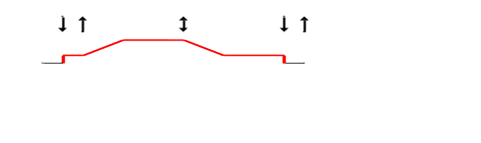

14 | Real time waveform control operation mode with initial current (intermittent up-down):  - Push the torch trigger: arc is ignited and current reaches the initial value.  - Release it: current gradually rises.  - Push it again: current stops rising.  - Release it: current drops gradually.  - Push it again: current stops dropping, and then turn to ②.  - If the torch trigger is not pushed after the current begins to drop, the current will drop gradually till arc stops. | 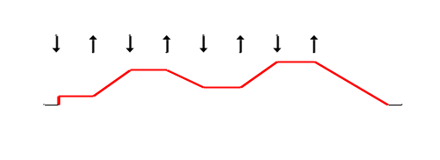
15 | Real time waveform control operation mode without initial current (intermittent up-down):  - Push the torch trigger: arc is ignited and current rises gradually.  - Release it: current stops rising.  - Push it again: current drops gradually.  - Release it: current stops dropping.  - Push it again: current rises gradually, and then turn to ②.  - If the torch trigger is not pushed after the current begins to drop, the current will drop gradually till arc stops. | 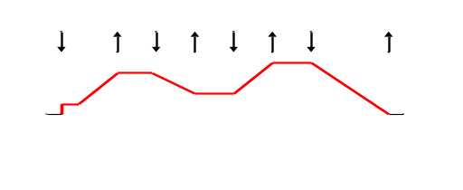
16 | Manual pulsed single operation mode:  - Push the torch trigger: arc is ignited and current reaches the preset value.  - Release it: current drops to pilot arc current value.  - Push it again: current rises to the preset value, and then turn to ②.  - If push the torch trigger and release it at once, or release the torch trigger and push it at once, arc will stop.  Note: Preset value is the peak value; pilot arc value is the base value. It is programmable. | 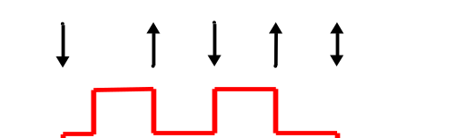
17 | Manual pulsed double operation mode:  - Push the torch trigger: arc is ignited and current reaches the preset value. The torch trigger can be released at any time.  - Push the torch trigger and release it at once: current drops to pilot arc current value.  - Push the torch trigger and release it at once: current rises to the preset value, and then turn to ②.  - If push the torch trigger twice within 0.5s, the current will drop gradually, and arc will stop.  Note: Preset value is the peak value; pilot arc value is the base value. It is programmable. | 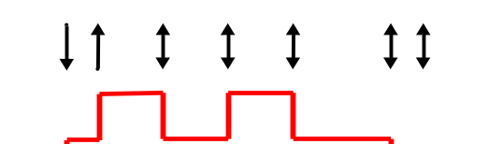

18 | Pulsed welding with fixed frequency (5Hz) and fixed duty cycle (50%):  - Push the torch trigger: arc is ignited and current reaches the initial value.  - Release it: current gradually rises.  - Push it again: current drops to pilot arc current value, and the timing function is started.  - If time is out, do peak-base switch.  - Release the torch trigger: arc stops.  Note: Preset value is the peak value; pilot arc value is the base value. It is programmable. | 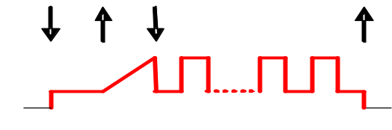
19 | Pulsed welding with unfixed frequency (the cycle is 1/5 of the upslope time) and fixed duty cycle (50%):  The same with that of mode 18. | The same with that of mode 18.
When reading the above table, please note:
- Whether arc ignited by HF or by striking the electrode, and no matter what kind of operation mode is selected, after arc is ignited successfully, it enters into initial current, and later into operational mode control.
- Some operation modes adopt the exit mode by pushing the torch trigger. The operator should release it after exiting welding. In this way, another welding operation can be entered by pushing the torch trigger.
- Current curves in all operation modes are drawn on the assumption that the machine works in DC TIG mode. If the machine works in pulsed TIG mode, the current curve appears a pulse shape; if the machine works in AC TIG mode, the current curve appears a variable polarity pulse shape.
- Customarily, the TIG operation modes most widely used are 2T and 4T, which exactly correspond to operation mode 2 and 4 for this machine respectively.
- Use the operation mode programming function carefully, since it is somewhat difficult.
5.7 Installation and operation in TIG
5.7.1 Installation in TIG
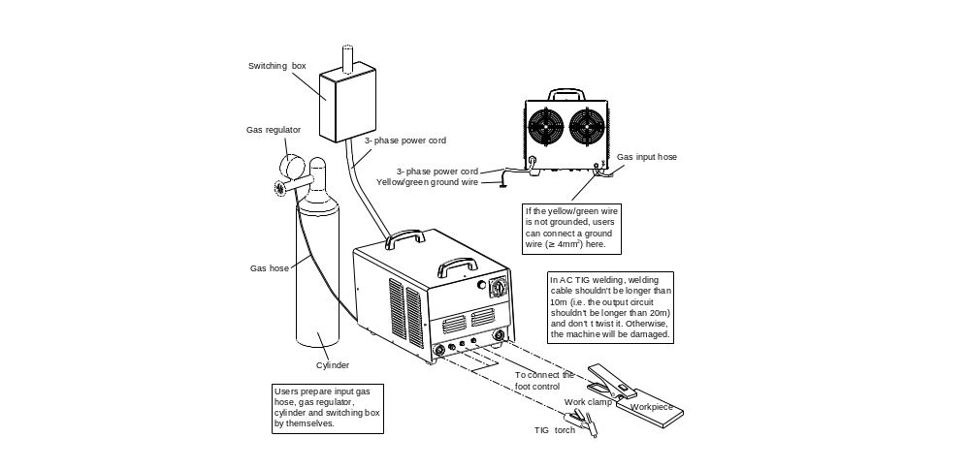
Sketch map of installation in TIG (for reference only)
Note:
- When in DC/pulsed TIG, the connection showed above is DCEN polarity. For DCEP polarity, exchange the plugs of the TIG torch and work clamp and insert into the corresponding output terminal, but it is only used in welding on some special materials. When in AC TIG welding, install the machine according to the above figure.
- Pay special attention to the marks for the output sockets and the like on the front panel: The ones in circle are needed in TIG, and the ones out of circle are needed in SMAW.
- Insert the cable plug with work clamp into the “” socket on the front panel of the welding machine, and tighten it clockwise. Clamp the workpiece with the work clamp.
- Insert the cable plug with TIG torch into the “” socket on the front panel of the welding machine, and tighten it clockwise. Insert the aviation plug on the TIG torch into the 2-pin aviation socket under the sign “” on the front panel of the machine, and tighten it clockwise. Connect the gas nozzle of TIG torch to the gas output terminal on the front panel of the machine, and tighten it clockwise.
- Select the proper gas hose with a proper length, and connect one end of it to the gas inlet on the back panel of the machine, and the other end to the gas outlet of gas regulator on the cylinder. All connection should be tight enough to avoid gas leak.
5.7.2 Operation of TIG
After making sure that all are correctly installed, close the power supply switch to start the machine. Select AC square wave TIG, AC pulsed TIG, DC TIG or DC pulsed TIG by pressing the welding mode selecting key on the front panel of the machine, or select welding mode such as TIG spot welding or composite waveform TIG welding by selecting operation mode. Open the gas valve of the cylinder, adjust the gas flow to the proper value, select the correct cooling mode, adjust all parameters to the proper value according to the relevant content in this manual, and TIG welding can be carried out. The arc ignition mode of this machine is noncontact arc ignition. During welding, the parameter display meter displays the welding current, and it can display the arc voltage by pressing the key in the parameter display selecting zone.
5.7.3 Foot control
Foot control function is generally used in TIG mode:
- Connect the foot control to the corresponding terminal on the front panel of machine with a special cable.
- Press the foot control selecting key on the front panel of the machine to lighten the foot control LED.
- Adjust the welding parameters to the proper value, and then welding can be carried out.
- When welding under foot control, TIG operation mode 0 is used, and it has nothing to do with the current operation mode setting.
- Step on the foot control to ignite arc in non-contact arc ignition mode. After arc is ignited successfully, the welding current will be controlled by the foot control. The minimum current value is 30A, while the maximum current is the preset value.
Note: Foot control is optional. Give your requirement when placing your order if necessary.
5.7.4 Application of automatic welding
Connect the computer with the communication interface RS-485 (It is optional, and give your requirement when placing your order if necessary.) of the machine; equip proper software; and computer-controlled automatic welding can be carried out. The communication protocol of automatic control is available against payment with this machine, while the computer software for automatic welding should be provided by users themselves.
5.8 Installation and operation in SMAW
5.8.1 Installation in SMAW
- Insert the cable plug with work clamp into the “” socket on the front panel of the welding machine, and tighten it clockwise.
- Insert the cable plug with electrode holder into the “” socket on the front panel of the welding machine, and tighten it clockwise.
For DC welding, the connection as mentioned above is DCEP polarity. Operator may choose DCEP/DCEN according to workpiece and electrode application requirement. Generally, DCEP polarity is recommended for basic electrode, while there is no special polarity requirement for acid electrode. For AC welding, there are no such names.
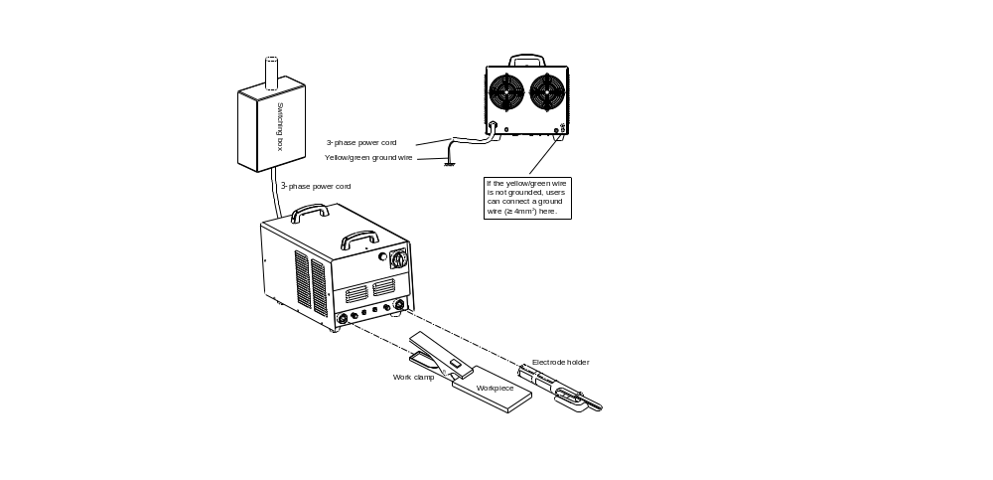
Sketch map of installation in SMAW (for reference only)
Note: The connection showed above is DCEP polarity. For DCEN polarity, exchange the plugs of the electrode holder and work clamp and insert into the corresponding output terminal.
5.8.2 Operation of SMAW (DC)
After connecting the cables and wires of the machine according to above figure, clamp the workpiece and the proper electrode with the work clamp and electrode holder respectively. After making sure that all are correctly installed, close the power switch to start the machine. If the welding mode is not pointing to “DC MMA”, press the key in the welding mode selecting zone on the front panel of the machine to select “” DC MMA mode. After adjusting all parameters according to relevant content in this manual, SMAW can be carried out. When welding, the digital meter displays the welding current, and it can also display the arc voltage if you press the key in the parameter and alarm display selecting zone.
5.8.3 Operation of SMAW (AC)
The only difference from that of SMAW (DC) is that the welding mode points to “”.

6. CAUTIONS
- Install and operate the machine strictly according to the relevant contents in this manual.
- Cut off the power before connecting the 3-phase AC input to avoid electric shock.
- The enclosure should be grounded reliably via the ground terminal on the back panel if the yellow/green wire of the power cord is not grounded.
- Keep the machine at least 30cm away from the wall, and at least 50cm away from the combustibles.
- Prevent sparks splashing onto the combustibles to avoid a fire.
- Avoid sparks entering into the machine through the vent.
- Do not use long welding cable in TIG welding.
- Do not discharge with the TIG welding torch pointing to someone.
- Only professionals can uncover the machine for there is high voltage inside the machine.
- Welders should always use protective equipment such as dry insulating gloves, insulating shoes and welding helmet in compliance with the safety standards.

7. MAINTENANCE
Maintenance of the machine
- Do not expose the machine in the sunlight for a long time.
- Do not put the machine in the rain, and avoid putting the machine in a humid environment.
- Check periodically whether inner circuit connection is in good condition (esp. plugs). Tighten the loose connection. If there is oxidization, remove it with sandpaper and then reconnect.
- Keep hands, hair and tools away from the moving parts such as the fan to avoid personal injury or machine damage.
- Clean the dust periodically with dry and clean compressed air. If welding environment with heavy smoke and pollution, the machine should be cleaned daily. The pressure of compressed air should be at a proper level in order to avoid the small parts inside the machine being damaged.
- Avoid rain, water and vapor infiltrating the machine. If there is, dry it and check the insulation of the equipment (including that between the connections and that between the connection and the enclosure). Only when there are no abnormal phenomena anymore, can the machine be used.
- Check periodically whether the insulation cover of all cables is in good condition. If there is any dilapidation, rewrap it or replace it.
- Check periodically whether the gas hose is in good condition. If there are any cracks, replace it.
- Put the machine into the original packing in dry location if it is not used for a long time.

 | Component explosion may cause injury.
- When the inverter welder is powered on, invalid components may explode or lead to explosion of other components.
- Wear face guard and long-sleeved clothing when maintaining the inverter welder.

 | Static causes damage to PCB.
- Wear a grounded antistatic wristband when carrying PCBs and components.
- Store, carry and transport PCBs with appropriate antistatic bags or boxes.

 | Electric shock may occur when testing.
- Cut off the power supply of the welder before lead testing.
- Test with an instrument with auto-fixing clamp on one of its leads.
- Read the instruction of the testing equipment carefully.

8. TROUBLESHOOTING
WARNING
The following operation requires sufficient professional knowledge on electric aspect and comprehensive safety knowledge. Operators should be holders of valid qualification certificates which can prove their skills and knowledge. Make sure the input cable of the machine is cut off from the electricity utility before uncovering the welding machine.

Electric shock can cause personal injury or even can kill.
8.1 General troubleshooting
The phenomena listed blow may be caused by the accessory and gas you use, the working environment or the power supply condition. Try to improve the working environment to avoid such occurrences.
Phenomena |  | Cause | Solution
The fan does not work or it works abnormally. |  | The 3-phase power cord is not well connected. | Reconnect the 3-phase power cord.
 |  | Phase failure | Solve the phase failure problem.
 |  | The mains voltage is overly low. | Welding can be carried out after the mains voltage recovers.
MMA | Hard to ignite arc | The arc ignition current is too low or the arc ignition time is too short. | Increase the arc ignition current or prolong the arc starting time properly.
MMA | Excessive spatter or the molten pool is too big. | The arc ignition current is too high or the arc ignition time is too long. | Reduce the arc ignition current or shorten the arc ignition time properly.
MMA | Normal arc can not be started. | Phase failure of the mains power supply or the power cord is not well connected. | Solve the phase failure problem or reconnect the power cord.
MMA | Electrode sticking | The arc force current is too low. | Increase the arc force current properly.
MMA | The electrode holder becomes very hot. | The rated current of the electrode holder is lower than its actual working current. | Replace it with a higher rated current.
MMA | Arc is easy to break. | Arc breaking voltage is too low. | Increase the arc breaking voltage.
TIG | There is no current output when pushing the torch trigger. | Welding can be exited when the torch trigger is pushed in some TIG operation mode. | Release the torch trigger and try again.
TIG | There is no current output when pushing the torch trigger. | The welding circuit is not in good connection. | Check the welding circuit, and reconnect it if necessary.
TIG | There is no discharge and arc cannot be ignited when pushing the torch trigger in HF arc ignition mode. | The torch trigger is not connected well. | Connect the torch trigger well.
TIG |  | The spark gap on the discharge board is too big. | Adjust the spark gap on the discharge board to about 1.0mm.

TIG | The electrode burns quickly in TIG welding. | The output polarity connection is incorrect. | Exchange the polarity.
TIG | The electrode burns quickly in TIG welding. | The cleaning strength is too big in AC mode. | Reduce the cleaning strength.
TIG | Black weld bead | The weld bead is not well protected and is oxidized. | Make sure the gas valve of the cylinder is open and the pressure inside the cylinder is high enough. Generally, it is necessary to refill the cylinder when the pressure is lower than 0.5MPa.
TIG | Black weld bead | The weld bead is not well protected and is oxidized. | Check if the gas flow is normal. You may select different gas flow according different welding current. However low the current is, the gas flow is recommended to be not less than 5L/min. Otherwise, the weld bead may not be fully covered for lack of shielded gas.
TIG | Black weld bead | The weld bead is not well protected and is oxidized. | Check if the gas path is airproof and if the gas is pure enough.
TIG | Black weld bead | The weld bead is not well protected and is oxidized. | Check if the environment is with strong wind.
TIG | Arc is hard to start but easy to break. | The electrode you use is of poor quality or is badly oxidized. | Replace it with electrode of better quality.
TIG | Arc is hard to start but easy to break. |  | Remove the oxidized layer of the electrode.
TIG | Arc is hard to start but easy to break. |  | Prolong the post-flow time to avoid oxidization of the electrode.
TIG | Arc is hard to start but easy to break. |  | Adjust the spark gap on the discharge board to about 1.0mm.
TIG | Unstable current during welding | Mains voltage fluctuates badly, or the input cable is loosely connected with the mains power supply. | Check the mains power supply for normal state, and reconnect the power cord.
TIG | Unstable current during welding | There is serious interference from other electric appliances | Do not connect the machine to the power cord which is connected to other electric appliances of serious interference.
Other malfunction |  |  | Contact the service center of our company.

8.2 Alarm & solution
Type | Alarm | Automatic response | Cause | Solution
Overcurrent | Overcurrent LED glitters and there are alarm beeps. | Cut off the main circuit permanently. | Load current is too high, or overcurrent protection of main power unit occurs. | Restart the machine. If the problem remains, shut down the machine and contact the maintenance professionals.
Undervoltage | Overvoltage/ undervoltage LED glitters and there are alarm beeps. | Cut off the main circuit temporarily. | The mains voltage is below 280VAC. | Problem will be automatically eliminated when the mains power supply recovers, and welding can be continued. If under-voltage sustains, ask the electrician to check the 3-phase power. Welding cannot be carried out until the mains power supply recovers. If the mains voltage is normal, but alarm beeps still exist, contact the maintenance professionals.
Overheating | Overheating LED glitters and there are alarm beeps. | Cut off the main circuit temporarily. | Excessive work of the main circuit | It is unnecessary to shut down the machine, but just wait for the overheating LED to go off, and then welding can be continued.
The machine may be damaged during welding. Timely maintenance should be carried out after the confirmation of damage. Only qualified individuals can uncover or repair the machine. Otherwise, further machine fault and further damage to valuable parts may occur.
To facilitate the maintenance of the welding machine, the wiring diagram of this machine is provided on the next page for your reference.

9. WIRING DIAGRAM
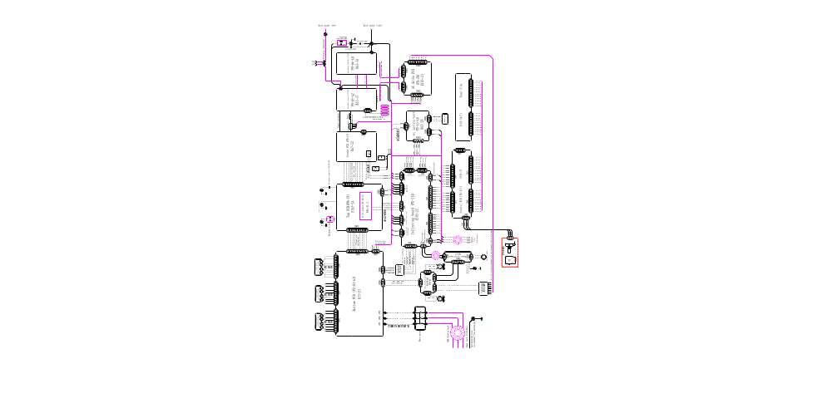

APPENDIX: PROGRAMMING GUIDE FOR USERS (TIG MODE)
Skip this chapter over if user-programming function (TIG mode) is not to be used.
4 programmable TIG operation modes (No.16-19) are available for this welding machine, and all the 4 modes are clearly defined when leave factory. Users can freely modify them to meet their special requirements according to the method provided in this chapter. Read this chapter carefully and fully understand all contents before the re-programming or modifications of the operation modes.
1. Operation of the torch trigger
It is the operation mode’s connotation that different operation of the torch trigger during welding lead to different current waveform. The operation of torch trigger typically includes the following forms:
⊙ Push the torch trigger (↓)
⊙ Release the torch trigger (↑)
⊙ Push the torch trigger and release it at once (↓↑)
⊙ Release the torch trigger and push it at once (↑↓)
⊙ Push the torch trigger twice within 0.5s (↓↑↓or↑↓↑↓)
⊙ Release the torch trigger twice within 0.5s (↑↓↑or↓↑↓↑)
These are the general descriptions of the operation of the torch trigger. In addition, descriptions based on operation times are used in this chapter.
- Single operation: Push or release the torch trigger.
- Double operation: Push and release the torch trigger within 0.5s, or release and push the torch trigger within 0.5s.
- Triple operation: Push, release and push the torch trigger within 0.5s, or release, push and release the torch trigger within 0.5s.
- Quartic operation: Push, release, push and release the torch trigger within 0.5s, or release, push, release and push the torch trigger within 0.5s.
2. Coding of operation mode
For digital welding machine, the function of TIG operation mode is realized by running an orderly code group. This orderly code group is called operation mode code sequence, and codes that composing of this sequence code are named operation mode codes. To plan and design a new TIG operation mode is actually to design a code sequence group and to program it into the welding machine. The code sequence of operation mode is composed of the following.
Operation mode code sequence: C0, C1, C2, C3, C4, C5, C6, C7, C8, C9
In this sequence, Ci (i stands for code no. 0~9) is a code in the code sequence. The code sequence of an operation mode is composed of 10 codes, and each code can be a number among 0~99. The meaning of all codes in the code sequence are detailed as below.
C0 is the no. 0 code in the sequence, and it defines the operation time of the operation mode:
C0=0~89 stands for that the operation time is 0.0~8.9s.
C0=9X stands for that the operation time is (X+1)/10 of the upslope time.
C1~C9 respectively stands for no.1~9 code in the sequence and also the operation stipulation of step 1~9. Different values of these codes stand for different operation stipulations. 100 codes are classified and explained in Attached Table 2 based on their functions and characteristics, and users should fully understand all those. For welding machine, operation mode is realized by implementing the code sequences one by one. Here Attached Figure 1 and Attached Figure 2 show the general steps to implement the code sequences.
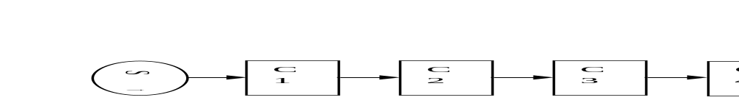
Attached Figure 1 Flow chart of operation sequences without code transfer
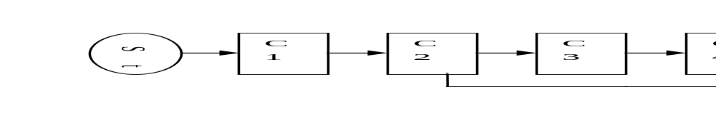
Attached Figure 2 Flow chart of operation sequences with code transfer
General steps for operation mode code sequence design:
- Function setting: set operation function according to the welding technical requirements.
- Function decomposing: decompose function referring to Attached Table 2 to bring out several sub-functions.
- Code selecting: select appropriate codes referring to Attached Table 2 to realize each sub-function.
- Sequence composing: arrange the order of codes appropriately to compose applicable code sequences.
Tips in operation mode code sequence design:
- During welding, users always enter into operation mode control after the torch trigger is pushed and arc is successfully ignited, so users do not need to care about the arc ignition requirements of welding in the code design.
- Operation mode control will be exited once arc stops. If users want to enter into it again, arc should be ignited for another time.
- Operation codes "1X" and "2X" are with a rapid response, while "3X", "4X" and "5X" are with a slow response, because it takes about 0.5s for the latter to collect the effective changes of torch trigger.
- Except C0, select “0” in any other codes means no operation and not turning to the next step (i.e. waiting).
- Since as many as 100 kinds of operation codes are available for this machine, there is more than one code sequence to achieve the specific operation function, and users only need to choose one of them.
- It should be stressed that not all the programming codes can be combined arbitrarily. Some code combinations do not make sense, and some can achieve some specific functions but against users’ habit. Therefore, users should pay attention when obtaining code combinations.
20 kinds of TIG operation modes are available for this machine, in which 0-15 are non-programmable, and 16-19 are programmable. Whether non-programmable ones or programmable ones, they are achieved by their own operation mode code sequences, which are obtained based on “Operation mode encoding rules” (see Attached Table 1). Please refer to the description of the operation modes in the text when reading this table.
Attached Table 1 TIG operation mode code sequences list
Mode no. | Code sequences |  |  |  |  |  |  |  |  |  | Description  (see the text for details)
Mode no. | C0 | C1 | C2 | C3 | C4 | C5 | C6 | C7 | C8 | C9 | Description  (see the text for details)
0 | 00 | 02 | 29 | 00 | 00 | 00 | 00 | 00 | 00 | 00 | Follow mode
1 | 90 | 02 | 60 | 07 | 20 | 00 | 00 | 00 | 00 | 00 | 1T/spot welding mode
2 | 00 | 04 | 27 | 14 | 92 | 00 | 00 | 00 | 00 | 00 | Standard 2T mode
3 | 00 | 04 | 20 | 17 | 20 | 14 | 92 | 00 | 00 | 00 | Double operation 2T mode
4 | 00 | 01 | 24 | 16 | 29 | 00 | 00 | 00 | 00 | 00 | Standard 4T mode
5 | 00 | 01 | 20 | 14 | 20 | 16 | 20 | 19 | 00 | 00 | Double operation 4T mode
6 | 00 | 04 | 36 | 34 | 92 | 00 | 00 | 00 | 00 | 00 | Cycle single operation mode without initial current
7 | 00 | 01 | 34 | 36 | 92 | 00 | 00 | 00 | 00 | 00 | Cycle single operation mode with initial current
8 | 10 | 04 | 74 | 09 | 20 | 17 | 20 | 14 | 94 | 00 | Inner timing operation mode
9 | 10 | 04 | 74 | 17 | 29 | 00 | 00 | 00 | 00 | 00 | Outer timing operation mode
10 | 00 | 04 | 20 | 46 | 20 | 44 | 92 | 00 | 00 | 00 | Cycle double operation mode without initial current
11 | 00 | 01 | 20 | 44 | 20 | 46 | 92 | 00 | 00 | 00 | Cycle double operation mode with initial current
12 | 00 | 04 | 26 | 19 | 00 | 00 | 00 | 00 | 00 | 00 | Single operation 3T mode
13 | 00 | 04 | 20 | 46 | 20 | 19 | 00 | 00 | 00 | 00 | Double operation 3T mode
14 | 00 | 01 | 24 | 15 | 27 | 18 | 92 | 00 | 00 | 00 | Real time waveform control operation mode with initial current (intermittent up-down)
15 | 00 | 04 | 25 | 17 | 28 | 14 | 92 | 00 | 00 | 00 | Real time waveform control operation mode without initial current (intermittent up-down)
16 | 00 | 02 | 33 | 32 | 92 | 00 | 00 | 00 | 00 | 00 | Manual pulsed single operation mode
17 | 00 | 02 | 20 | 43 | 20 | 42 | 92 | 00 | 00 | 00 | Manual pulsed double operation mode
18 | 01 | 01 | 24 | 13 | 76 | 09 | 02 | 73 | 09 | 00 | Pulsed welding with fixed frequency (5Hz) and fixed duty cycle (50%)
19 | 90 | 01 | 24 | 13 | 76 | 09 | 02 | 73 | 09 | 00 | Pulsed welding with unfixed frequency (the cycle is 1/5 of the upslope time) and fixed duty cycle (50%)

Attached Table 2 TIG operation mode code function
Code | Operation stipulation | Code | Operation stipulation
0X | Immediate executive code:  Execute order X immediately. | 5X | Transfer code in torch trigger operation condition:  Wait for the torch trigger operation. Stop arc if triple or quartic operation, turn to next step if single operation, and if double operation:  X＝0: Turn to next step  X≠0: Turn to Step X (X=0~9)
1X | Executive code in torch trigger operation condition:  Wait for the torch trigger operation, and execute order X when pushing the torch trigger. | 6X | Timing executive code:  Wait for the operation time, and during this period, no influence if single or double operation, stop arc if triple or quartic operation. If no operation of the torch trigger and time is up, execute order X.
2X | Executive code in torch trigger operation condition:  Wait for the torch trigger operation, and execute order X when releasing the torch trigger. | 7X | Timing transfer code:  Wait for the operation time, and during this period, turn to next step if single or double operation, stop arc if triple or quartic operation. If no operation of the torch trigger:  X＝0: Turn to next step  X≠0: Turn to Step X (X=0~9)
3X | Executive code in torch trigger operation condition:  Wait for the torch trigger operation. If single operation, execute order X. Otherwise, stop arc. | 8X | Transfer code with torch trigger state:  X＝0: Turn to next step immediately  X≠0: Turn to Step X if the torch trigger is pushed. Otherwise, turn to next step. (X=0~9)
4X | Executive code in torch trigger operation condition:  Wait for the torch trigger operation. If single operation, no influence; if double operation, execute order X; if triple or quartic operation, stop arc. | 9X | Immediate transfer code:  X＝0: Turn to next step  X≠0: Turn to Step X (X=0~9)
The definition of order X:
X＝0: Turn to next step
X＝1: Go to the initial current and turn to next step
X＝2: Go to the preset current and turn to next step
X＝3: Go to the pilot arc current and turn to next step
X＝4: Upslope and turn to next step
X＝5: Stop upslope and turn to next step
X＝6: Downslope to the pilot arc and turn to next step
X＝7: Downslope till arc stops and turn to next step
X＝8: Stop downslope and turn to next step
X＝9: Stop arc

3. Operation mode programming
After designing a group of operation code sequence, you can enter into the operation mode programming state and input the code sequence into the machine. The main steps of operation mode programming are described as below.
- Access programming state
Press the TIG parameter selecting right shift key to start the machine, and the digital meter displays the glittering “P-2”. After about 5s, “P-2” disappears and “16” appears, and “” LED turns on, which means that the programming state has been accessed. Note: If no operation within 5min after accessing the programming state, it will exit automatically.
- Select operation mode no.
After you access operation mode programming state, “16” displayed on the digital meter stands for the operation mode 16, and you can select the operation mode to be programmed with the adjustment knob. (Operation mode no. for your selection is 16-19.)
- Enter into code editing state
After the operation mode no. is determined, you can press the parameter display selecting key, and the operation mode LED “” glitters. This means you have entered into code editing state.
- Code no. selecting and code content editing
After you enter into code editing state, the digital meter will display a 3-figure number, of which the glittering higher one stands for the operation mode code sequence no. and the lower two refer to the code content. You can change the code no. (0~9) by pressing the TIG parameter selecting right/left shift key and edit the code content (0~99) by turning the adjustment knob.
- Exit code editing state
After you finish editing an operation mode, you can exit code editing state by pressing the parameter display selecting key.
- Exit programming state
After making sure that the edited code is correct, and that you are not going to edit any other operation modes, you can exit programming state by pressing the MMA parameter selecting key.
The machine will run into normal operation after exiting operation mode programming state. Users can select TIG parameters appropriately, and check whether the code sequence designed and edited can achieve the desired function by test-welding.

We are still constantly improving this welder, therefore, some parts of this welder may be changed in order to achieve the better quality, but the main functions and operations will not be alternated. Your understanding would be greatly appreciated.

